**Ideation Phase**

**Empathize & Discover**

|  |  |
| --- | --- |
| Date | 26 September 2022 |
| Team ID | PNT2022TMID12468 |
| Project Name | Containment Zone Alerting Application |
| Maximum Marks | 4 Marks |

Empathy Map

CONTAINMENT ZONE ALERTING

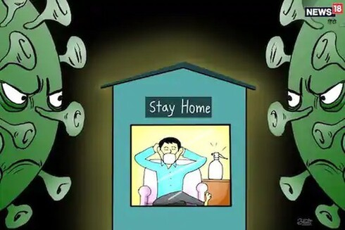

**HAPPY TO HAVE GOOD QUALITY SOFTWARE**

**COLLECTIVE MORE INFORMATION**

**I FEEL FOCUSED ALL KIND OF SITUATION**

**CHECKS THE WEBSITE**

**I FEEL FEAR ABOUT PROJECT AND ALSO EXCITED**

**COMPARE MORE THAN OTHER APPLICATION**

**IS THIS REALLY WORTH IT**

**I WAS EXPECTING SOMETHING DIFFERENT**

**DOESN'T HAVE TIME FOR ANALYSIS THE PROJECT**

**INTERACTION WITH TEAM MEMBERS**

**I WANT TO BE ABLE TO WORK MORE QUICKLY**

**I HOPE MAKE THE RIGHT CHOICE**